Department:

Higher Education and Training

3 REPUBLIC OF SOUTH AFRICA

|  |  |
| --- | --- |
| |  | | --- | | MARKING GUIDELINE | |

# NATIONAL CERTIFICATE

APRIL EXAMINATION

STRENGTH OF MATERIALS AND STRUCTURES N6

# APRIL 2013

This marking guideline consists of 7 pagesu



## QUESTION 1

Oaicuiate power to be transmitted

1.1 Wab 5k x 0.3 X 025

937.5

0.8

## = 1768,06 1V111

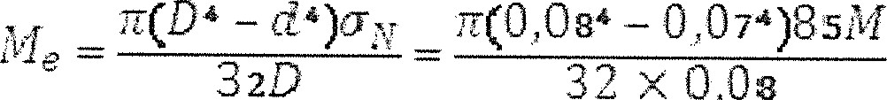

32D

|  |
| --- |
| 937.52 |

937,5 +

 2423/61 a:Vrn

- 0.07965M

2 704,1dVm 16 x 0,08

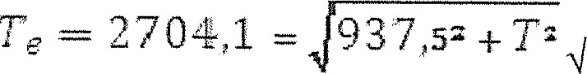

253 6,39Nm

Max Torque = 2423,61 Nmq

### ILIea7'1 2423,61

2144J8gNm

G enzici 1,13

Povcer

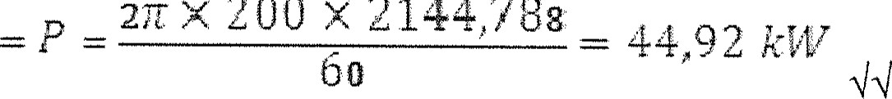

200

x

2144,788

### Drywing[15]



### QUESTION 2

2.1 Magnitude force F

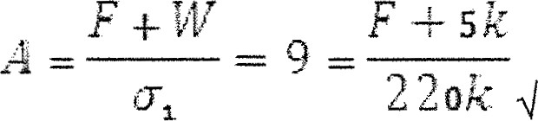

F

+

5k



#### F = 1,975 MN (3)

2.2 H-Section

 1,975M

## 23235 x

### 305 305 198 (3)

2.3 Actual stress in column

1,975M

78,249 MPG

|  |  |
| --- | --- |
| 25/24 x |  |

(2)

|  |  |  |  |
| --- | --- | --- | --- |
| QUESTION 3 | | (THREE marks for any one) | [8] |
| 3.1 | 6R = (300k X 2) + (8k x 6 x 6/2  R 124 klV  OR  6  = (330k X  2  L 224  OR |
|  | M = (224k X 2) - (8k X 2 | 432 |  |
| M = (124k x 432 klVm. | |
|  | (THREE marks for any one) | | (6) |

TI

Depth and breadth of beam

## O,5D I & â = D O, 15D

15 (0,85D

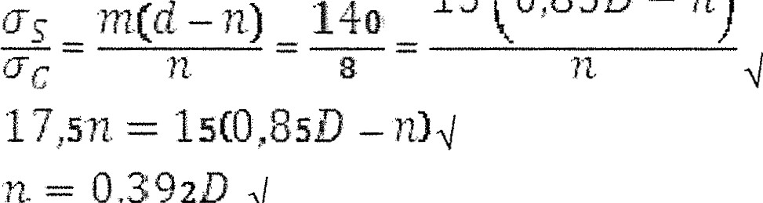

n)

0,392D

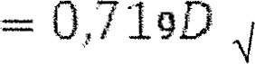0,392D o:d5D

3 3

1

432k = -X x x 0,392D x

2

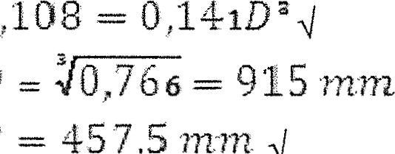

D

B

457,5

(9)

### QUESTION 4

4.1 Max tensile stress

F 200k

Ã = 3,219 62,13 MPa(T)

VVL look x 3

— 324,393 MPa

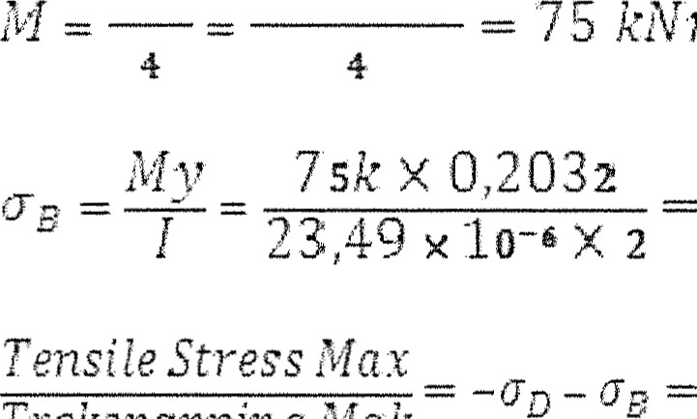

k}Vln

Trekspanning

Blak

-62,13111 -  = 386,523 (T)

(6)

42 Position of NA

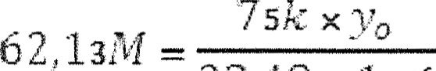

23,49 x 10-6 4 from G

19 ,46 mm 

#### Vanaf G (2)

[8]



### Qt!ESTlON 5

5.1 Allowable length

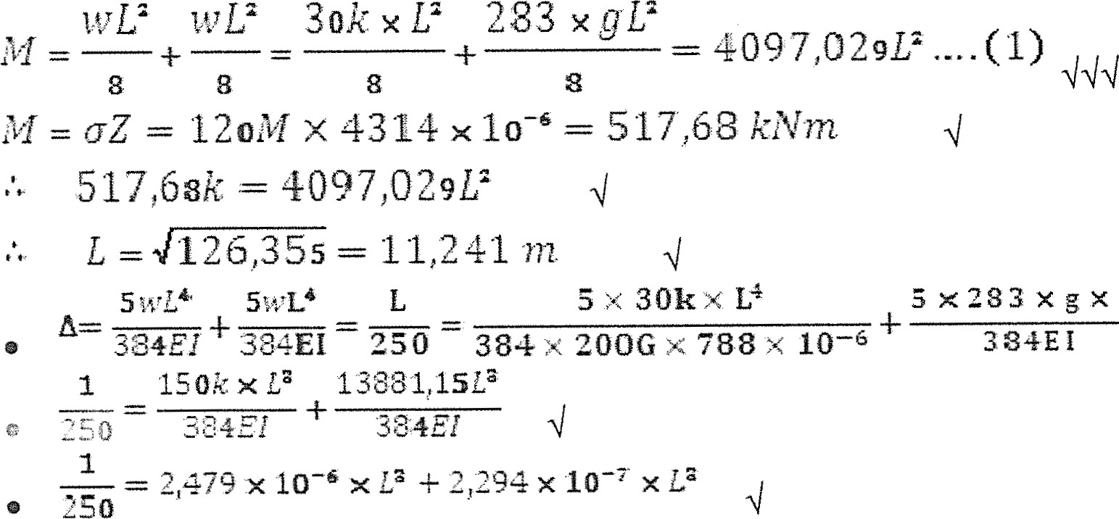

a

5x283xgxL4

|  |
| --- |
| 1 |
|  |

|  |  |  |
| --- | --- | --- |
|  | Use the length = 1 1 ,241 mm/ | (12) |
| 5.2 | Max slope |  |

3 — 11,338

o

o 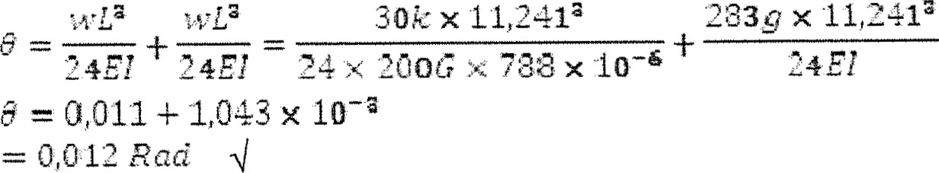 (3)

[15]

### QUESTION 6

6.1 Outside diameter

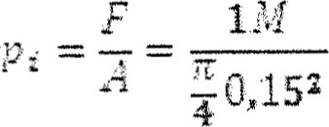= upa

3



:

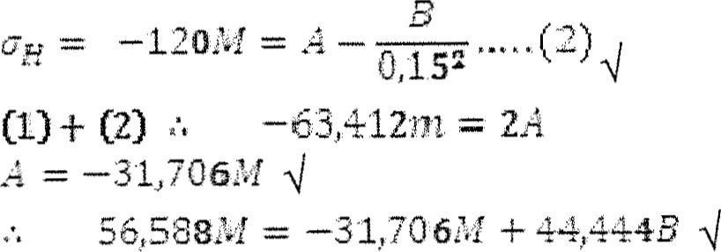

B = 1987M Al

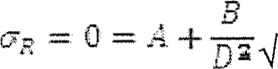

|  |
| --- |
|  |
| 31,76 |

= 250 (8)

6.2 Longitudinal stress

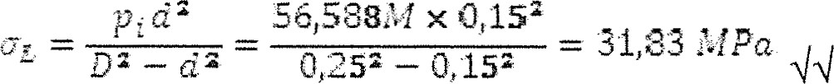 (2)

6.3 Strain at D

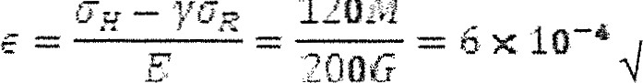

120M

### QUESTION 7

7.1 Position of RGR

1



2

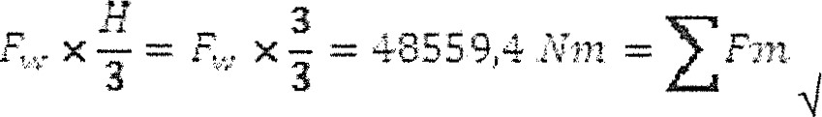

1

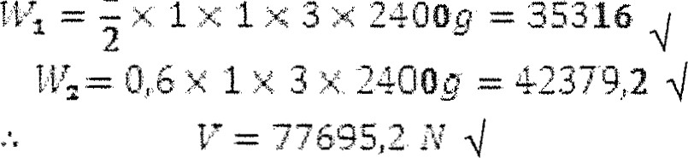



2

wax. = x = 5509296 Al

7863636

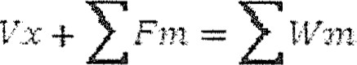

 7863696 from toe

X = .3:37i124

vanaf toon

|  |  |
| --- | --- |
| 3 1600  From  G  7.2 Depth of water | (1 1) |

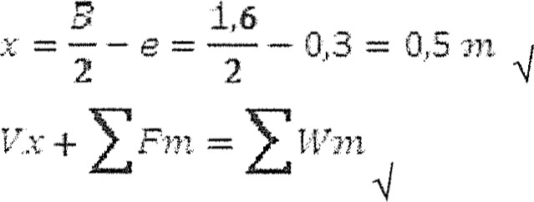

 0,5 + = 7363496

#### (L)

1

= -X 11009 =

2

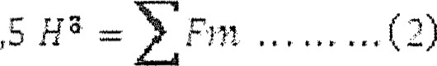5395.5K Z X— 3 3

(2) (1)

 (7)

[18]





8.1 Length of rope on ground:

= 153,846

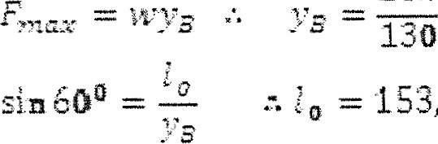 = 153,846 sin = 133,235

Length on ground

= 160- 133,235 -

Lengte op gronä(6)

8.2 Height of tower

COs 60 c 153,846 x 600 = -'4923 m

#### Height

= 153t346— 76,923 = 76,923

Hoogte (3)

8.3 Max tension in rope

= 130k x 76,923 = 10

[10]

 TOTAL: 100

Copyright